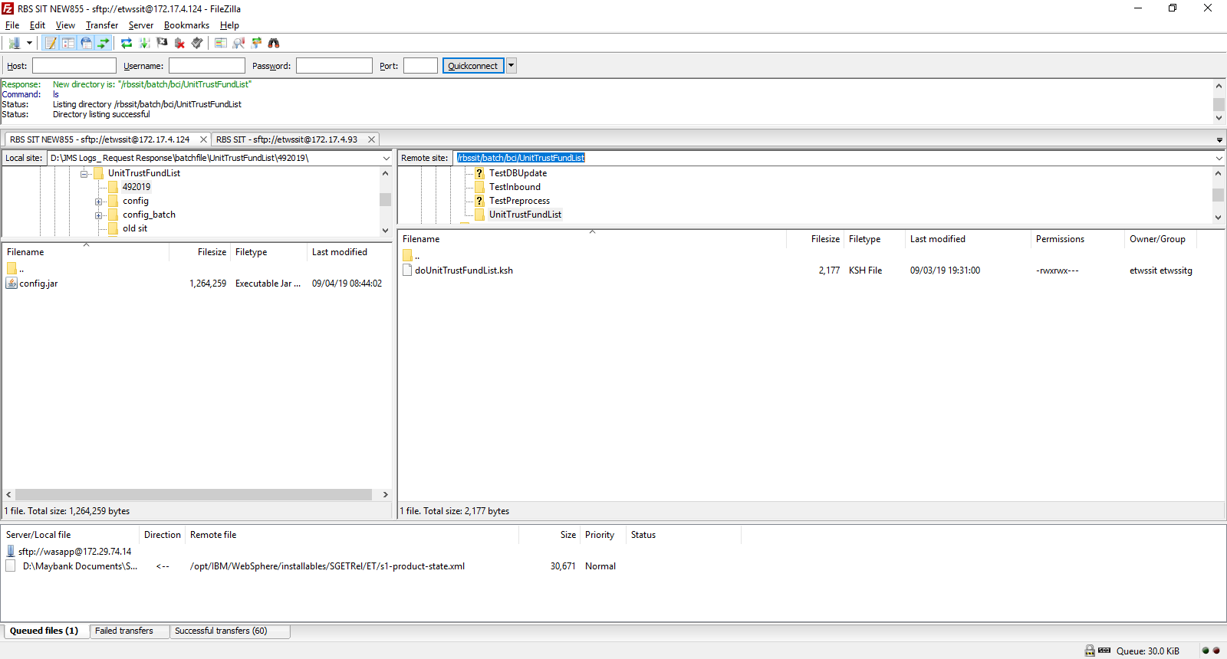

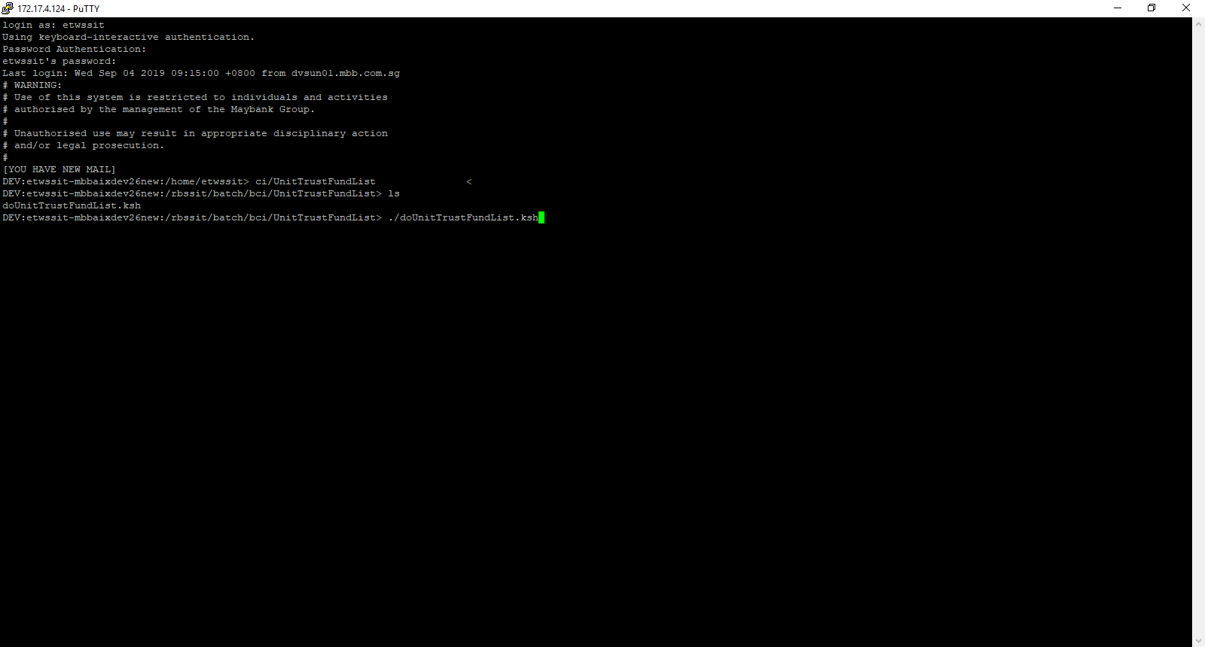

Ipaddress – 172.17.4.124

Putty : username – etwssit

Password – qwer1234

Java file in - /rbssit/batch/bci/config/SGPostalCode

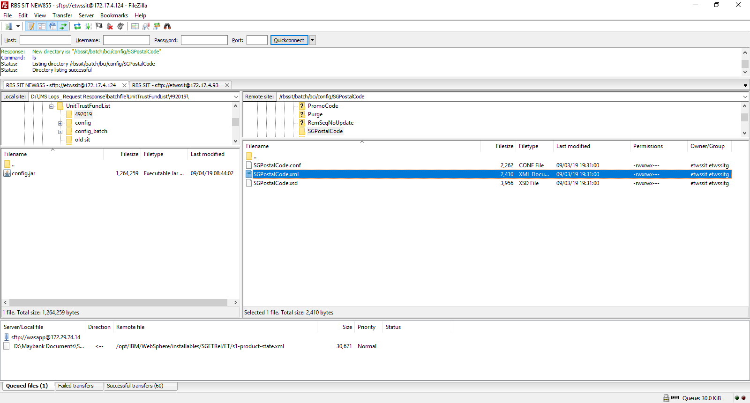

Data input -- /rbssit/batch/transfer/receive

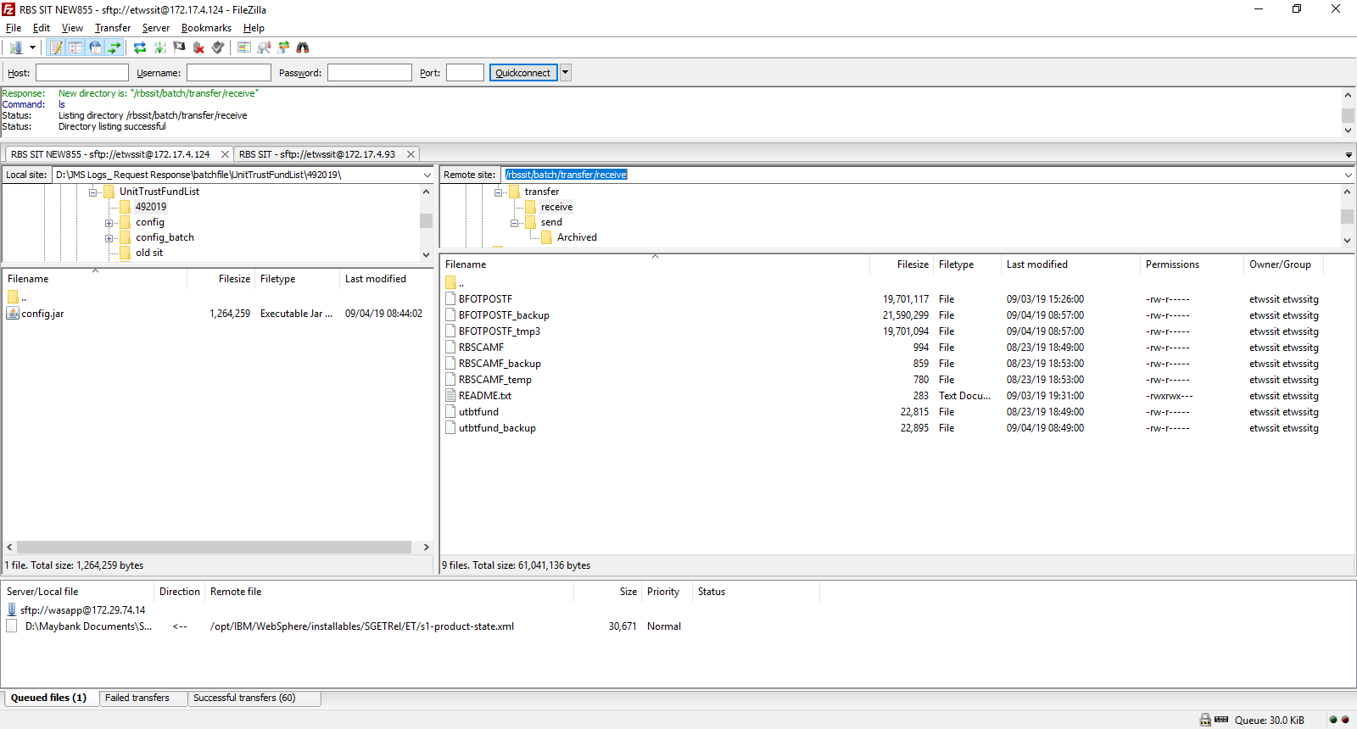

Error checking - /rbssit/batch/data/ SGPostalCode-20190904-085634-0000 